Ennio da Silva Vitor –

Computing Systems & Principles
Personal Computer Build Research Project

College of Computing Technology (CCT)
21/10/2015
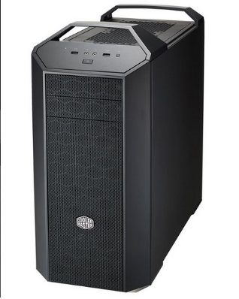
Hardware
Name: Cooler Master Master Case Pro 5
Place of purchase: http://www.komplett.ie/
Item cost with shipping: € 149.00

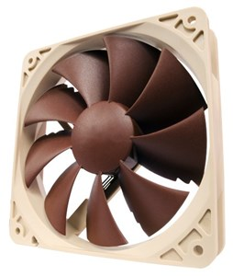
Name: Case Fan/ Cooler master V1200-1200 Watt/ 1300rpm, 54.3cfm, 19.8 dB
Place of purchase: http://www.komplett.ie/
Item cost with shipping: € 19.95

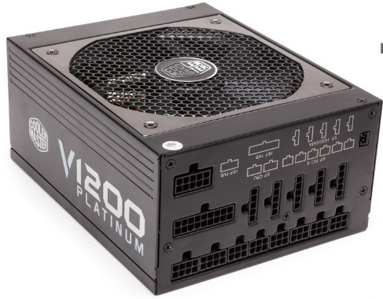
Name: Cooler master V1200-1200 Watt
Place of purchase: http://www.komplett.ie/
Item cost with shipping: € 259.00

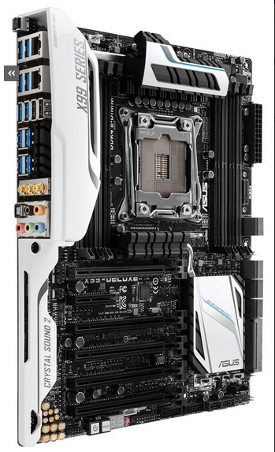

Name: A ASUS X99 – Deluxe/U3.1 – Socket 2011-3 – ATX
Shipset: Intel X99
Place of purchase: http://www.komplett.ie/
Item cost with Shipping: € 429.00

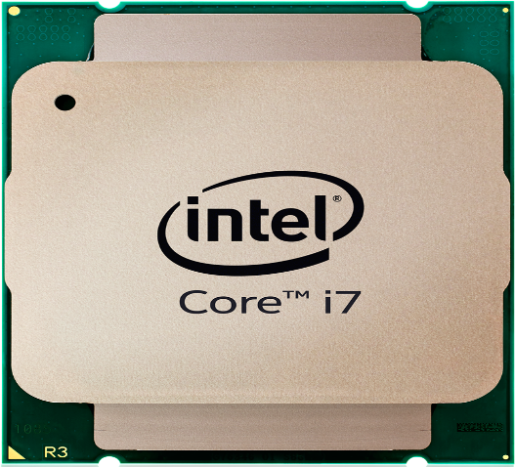
Name: Intel Core i7-5960X - 3GHz - Socket 2011-3
Place of purchase: http://www.komplett.ie/
Item cost with Shipping: € 1,199.00

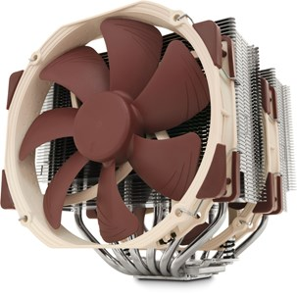
Name: Noctua NH-D15 - 140mm
Place of purchase: http://www.komplett.ie/
Item cost with Shipping: € 89.95

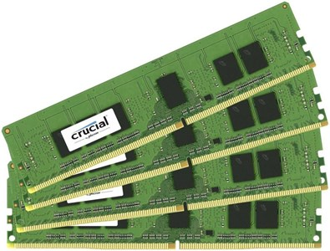
Name: Crucial 32GB - PC4-17000 – DIMM
Place of purchase: http://www.komplett.ie/
Item cost with Shipping: 2 x € 364.05 = € 728.10

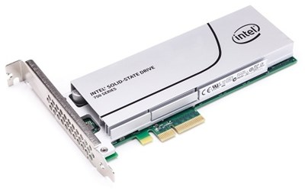
Name: Intel SSD 750 Series 1.2TB (HHHL) - bracket
Place of purchase: http://www.komplett.ie/
Item cost with Shipping: € 1,149.00

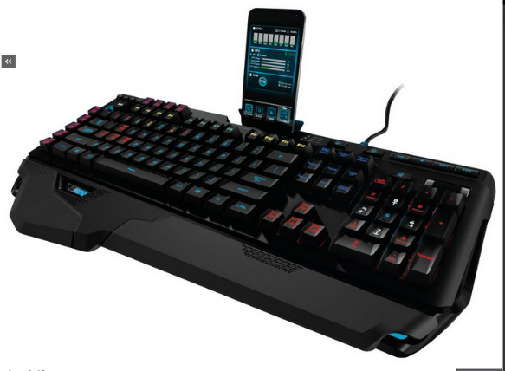
Name: Logitech G910 Orion Spark
Place of purchase: http://www.komplett.ie/
Item cost with Shipping: € 199.00

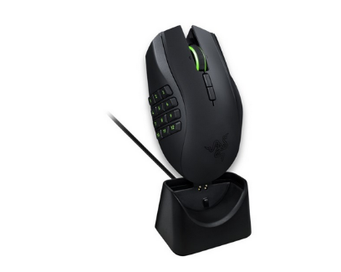
Name: Razer Naga Epic Chroma – Laser
Place of purchase: http://www.komplett.ie/
Item cost with Shipping: € 149.00

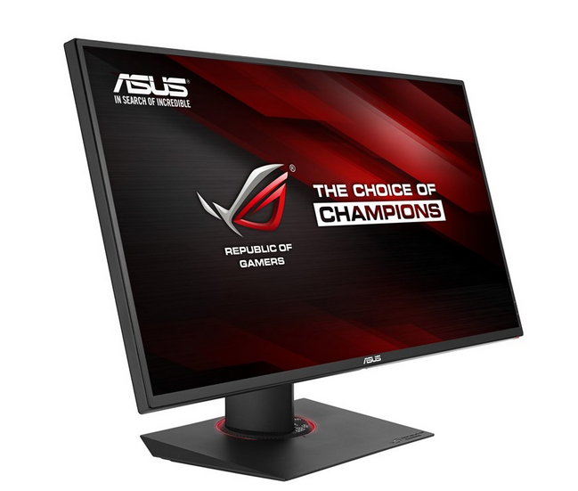
Name: ASUS ROG SWIFT PG278Q - 27"
Place of purchase: http://www.komplett.ie/
Item cost with Shipping: € 769.00

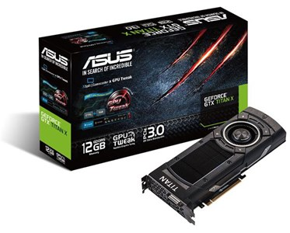
Name: Asus GeForce GTX TITAN X -12GD5 - 12GB - PCI-E
Place of purchase: http://www.komplett.ie/
Item cost with Shipping: € 1,199.00

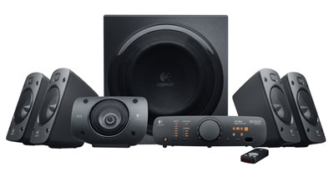
Name: Logitech Speaker System Z906
Place of purchase: http://www.komplett.ie/
Item cost with Shipping: € 349.00

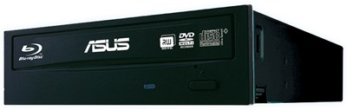
Name: ASUS BW-16D1HT 16x - Blu-Ray burner
Place of purchase: http://www.komplett.ie/
Item cost with Shipping: € 89.95

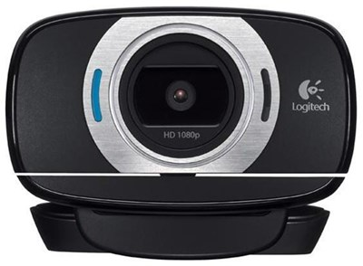
Name: Logitech HD Webcam C615
Place of purchase: http://www.komplett.ie/
Item cost with Shipping: € 69.95

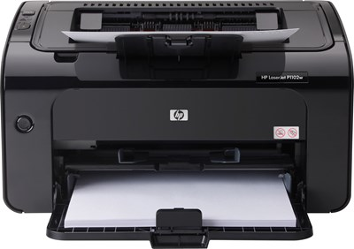
Name: HP LaserJet P1102w
Place of purchase: http://www.komplett.ie/
Item cost with Shipping: € 99.00

Name: Speedlink Spes Clip-On Lapel Microphone
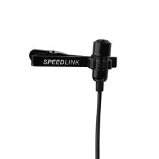
Place of purchase: http://www.ebay.ie/
Item cost with Shipping: € 11.51


Name: Cooler Master IC Essential E1
Place of purchase: http://www.komplett.ie/
Item cost with Shipping: € 5.95

Power Supply
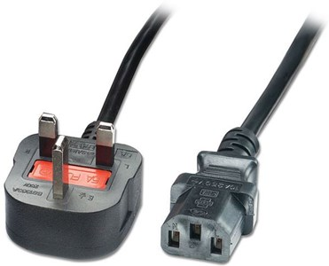
Name: Intronics power cable - 2.5 metres
Place of purchase: http://www.komplett.ie/
Item cost with Shipping: € 4.95

Tools
Name: StarTech11 Piece PC Computer Tool Kit with Carrying Case NEW CTK200
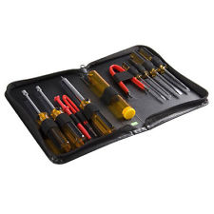
Place of purchase: http://www.ebay.ie/
Item cost with Shipping: € 17.65

Name: 10 Pcs PC PCB Motherboard Brass Standoff Hexagonal Spacer M3 7+4mm WH

Place of purchase: http://www.ebay.ie/
Item cost with Shipping: € 4.04

Notes
The reason of all the cables, screws or drivers from the primary and periheral components of the computer are not listed in this document is because they are included in the package already.

Softwares

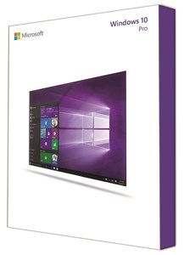
Name: Microsoft Windows 10 Pro 64-bit, OEM/ 1 licence - English
Place of purchase: http://www.ebay.ie/
Item cost with Shipping: € 169.00

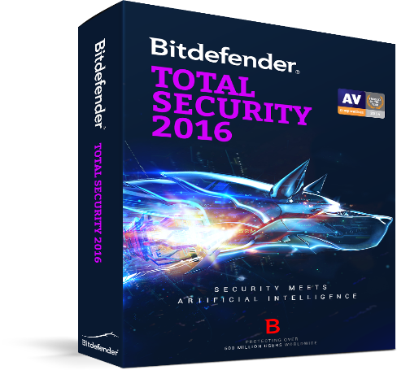
Name: Bit defender total security 2016/ 1 year of licence - English
Place of purchase: http://www.bitdefender.co.uk/
Item cost with Shipping: € 52.58


Name: Microsoft Office 2013 Home and Business/ 1 licence - English
Place of purchase: http://www.bitdefender.co.uk/
Item cost with Shipping: € 219.00

Bitdefender TOTAL SECURITY 2016

TOTAL SECURITY 2016

Price
Subtotal of Hardware: € 6,991.00
Subtotal of Software: € 440.58
Total: € 7,431.58

Steps to build the A ASUS X99 – Deluxe/U3.1 – Socket 2011-3 – ATX Computer.
The parts of this computer is based on the needs to run games, the idea is to have a computer that will last longer without upgrade anypart of the Hardware.
The first step I had considered was to find a great motherboard whith will support the best CPU for games at the moment. And, From that, I have got the information to decide which case to buy, it is simple design but offers a lots os windows to refresh the air that will cool down the machine.
And now I have the way to conect the Intel processor i7 and a powerfull cooler that will keep the temperature in a regular level of operation. ( I didn’t chose a water cooler because an Intel processor works with less power than a IMD processor).
To the next I had installed the case fan with 1300rpm that will supply enough air to the motherboard. Then, just conect the memory RAM 8 x 8 GB, conectar SSD 1.2 TB in the PCI, ( this is faster, spend less energy and heating then SATA HDs), after is the time to instal the ASUS GForce 12G on the PCI-E. Now just conect the motherboard on the case, connect and plug the power supply, connect and plug the blue-ray.
There is not a better audio supply because the one from the motherboard is enough for the moment.
Test if the parts are working (swiching on the machine).
Close the case, and conect the monitor, keyboard, mouse, webcam, speakers, printer
and microphone on the USB conections from the motherboard.
Install the operational sistem, drivers, antivirus and office pack.
Now the computer is read to be used.

What does it mean to have virtualization on the CPU and what benefit would it provide?
The CPU by itself works to run only one operational system per time, it will take all the information of the Hardware and sand to the operational system. The virtualization occur when one software is installed in the first operational system and this software will have direct contact with the physical CPU that will allow the software to have contact with the Motherboard. From that, is possible to install a new operational system (inside of the software) and it will run in the same time as the first operational system is working.
The benefit of the virtualization is: Is possible to test a new version of an operational system without have to install it in the physical machine for example.
Other good solution is: Only one physical computer can be connected with different desks with (monitor, keyboard and mouse) and each desk will be able to run different operational systems with different tasks in the same time.

Describe the virtualization technologies that are found on the Intel and AMD CPUS.
Intel and AMD basically focus the virtualization system on servers. The idea is: Do more with less enforce, on this case a company (main user of this technology) will spend less money to build a server.
The two companies also offer more speed to process data, Reduction of storage and network latencies and security system that will protect the physical machine against potential virus that would attack the machine before the authorised virtual machine access the motherboard.
Continuing with the security system, Intel looks to be more efficient then AMD, at the moment to prove if the virtual machine is authentic or it is a virus.
Other point is, as Intel processors as faster and spend less power to work then AMD processors, it shows that Intel processors will be more efficient then AMD to run many virtual machines in once.

References
http://www.ebay.ie/
http://www.komplett.ie/
http://www.amd.com/en-us/products/processors/desktop/a-series-apu
http://www.amd.com/en-us/products/processors/desktop/fx
http://ark.intel.com/products/82930/Intel-Core-i7-5960X-Processor-Extreme-Edition-20M-Cache-up-to-3_50-GHz
http://www.wisegeek.com/what-is-cpu-virtualization.htm
http://www.wisegeek.com/what-is-cpu-virtualization.htm#didyouknowout

I declare that the work submitted is my own. Signed:

Ennio da Silva Vitor - 2015197

TOTAL SECURITY 2016

TOTAL SECURITY 2016

TOTAL SECURITY 2

